BRAND STANDARDS & GUIDELINES
September 2022
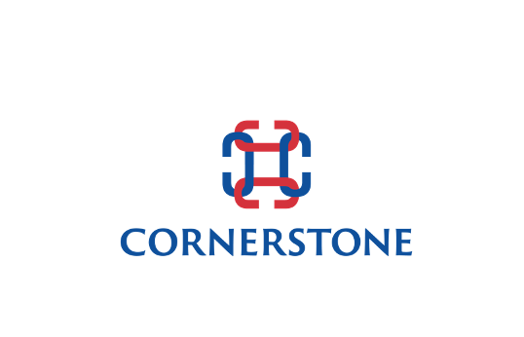



Table of Contents

- Why Our Brand is Important 1

Purpose of a Brand Book 1
- Our Brand Platform 2
Brand essence 2
Brand positioning 2
Brand values 3
- Corporate Name 4
Presentation of the name 4
- Logo & Taglines 5
Logos 5
Borders 6
Space 6
Backgrounds 6
Resolutions 7
Logo fonts 7
Web fonts 7
Colors 8
Partner logos 9
Taglines 10
- Brand Usage Web 11
Online situations 11
Member’s principal business website 11
Member profile on CIG global site 12
Fully branded CIG mini-site 12
- Brand Usage Offline 13
Email address 13
Business card 13
Stationery 14
Marketing Material 15
- Where to find resources 16
General enquiries 16
Fonts 17
Downloadable graphic files 17
Logos 17
Letterhead 17
Print presentation 18
PowerPoint 18

PRINTING
- We recommend producing a printed copy of this guide as a ready reference.
- The pages are formatted for two-sided printing with offset margins for left and right hand pages.
- The book should be spiral bound on the short side.
- Choose a heavier stock for the front and back cover and add a clear plastic over the front cover.

Why Our Brand is Important
Brands are more important today than ever. In a crowded environment, they convey a promise of consistent quality, credibility, and experience.
They identify and differentiate.

Because of its structure, Cornerstone International Group has an additional reason to develop awareness of a corporate brand.

The competitive power of CIG is drawn from its network of established, independent search firms who are among the leaders in their respective markets.
To create and apply this power, all members of the network must be seen as elements of an integrated, trusted and solution-providing entity.
To communicate this unique structure is the task of our brand – Cornerstone International Group.

Purpose of a Brand Book
Clients and business audiences will form an opinion of Cornerstone International Group by how they see the brand used. As a result, it will represent more than one thing at any time.
For the brand to communicate the values WE want; it is critical that brand usage be clearly defined and consistent at all times.

The purpose of this Brand Book is to help us work together to establish consistent, branded communications and marketing that builds awareness of the Cornerstone International Group network in the communities our members serve. In this book:
- We specify the accepted physical parameters governing presentation of our corporate name, logo (in various forms) and tagline. Physical parameters are style and size of font, space and proportion, and color.
- We present guidelines governing where and when the use of the Cornerstone International Group brand is required.

Our Brand Platform
The biggest task of our brand is to present our members as belonging to one provider in the eyes of the client. However, it does much more and our brand platform contains several positioning themes.

Brand Essence
The essence of our brand is the core idea. Our core idea is bringing together established and successful businesses in retained search and leadership development and delivering coordinated, world-calibre solutions for clients in any geographical market.

Brand Positioning

Our brand positioning is Cornerstone is a trusted partner dedicated to assisting its clients become even more successful. It carries out this mission by unifying the best available talents with its clients, and in so doing promotes their growth, productivity, and success.

Who we are: Cornerstone is a globally recognized talent solutions group. Founded in 1989, we have grown to encompass 60 offices in 40 countries. Our clients have come to see us as partners in three critical business areas: acquiring strategic talent, coaching managers to expand their capacities as leaders, and providing career navigation support. Our local experience, global reach and ownership mindset enable our clients to succeed and grow worldwide.
How we work: our members are retained executive search specialists, meaning they work exclusively under contract to identify, qualify, and engage the best person to meet the agreed needs of the client.
What differentiates us: through our structure, we have unparalleled diversity of skill sets, proven leadership in distinct markets and a one-window relationship with international companies.

Brand Values
Our brand represents our values, which in turn represent our core beliefs. These are:
Understanding: We are empathetic and respectful. While we are proud of our heritage since 1989, we take more pride in the success of our clients.
Dependable: We are committed to our word. We deliver what we say we promised to do.
Human: We are empathetic to corporate needs, both locally and globally.
Inspiring: We believe a positive “can do” attitude is the cornerstone of our business success and can be an inspiration to others. Cornerstone partners with client companies to find and grow their extraordinary people as new building blocks of their future success.

Brand Attributes

Human: We are approachable, warm, relaxed, and talented advisors in every corner of the world.

Direct: We are focused, straightforward, and easy to work with.

Inspiring: We are alive with a vibrant, refreshing, and infectious energy of doing good as Cornerstone.

Understanding: We are empathetic and respectful, and while we have been proud of our heritage since 1989, we take more pride in the success of our clients.

Dependable: We are committed to our word and earnestly do what we say we shall do.

Corporate Name

Presentation of the name
The registered name of the organization is Cornerstone International Group and should be presented in full wherever possible.
When used as a logo, the three words are always capitalized, as shown in the next chapter. In a text environment, the first letter only of each word must be capitalized.
When used frequently, as in an article or blog post, the name may be abbreviated to the initials CIG. This should always follow presentation of the abbreviation in association with the full name, as in the following: Cornerstone International Group (CIG).
CIG is the preferred abbreviation, since several other firms use versions of our registered name. Exceptions include the identification of members whose legal brand does not identify Cornerstone International Group. The accepted protocol in this case is to use the word Cornerstone + the Location, as in this example:
Ratliff & Taylor – Cornerstone Cleveland

The word Cornerstone alone can be used in headings, but the full name should appear in the first two paragraphs.

Logo & Taglines

Logos
The full Cornerstone International Group logo appears as a square and as a rectangle.

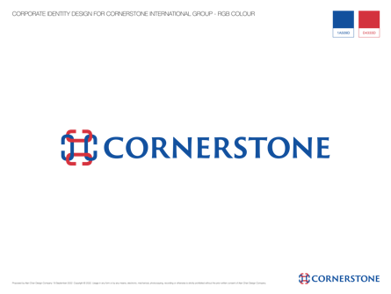 a. Horizontal with symbol and “Cornerstone”.

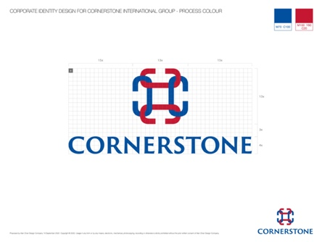 b. Vertical symbol and “Cornerstone.”
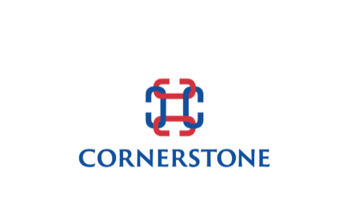 c. An interlocking shape of four-letter 'C'. The main design is one line connecting four letter C’s. The four-C’s demonstrates Cornerstones are in all four corners of the earth and when you add key talents that are cornerstones, you add growth. 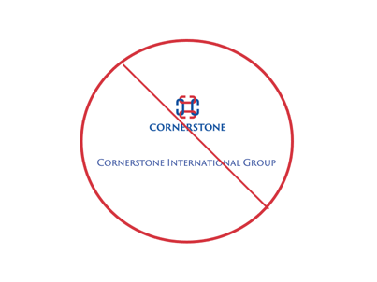 d. We do not put executive search or international group with the new symbol, nor do we describe our executive search in our new logo, as we are more than an executive search group.

Office Logos
All individual office logos can be found on the Members Only Dashboard
- Category: Brand Assets/Logos
  - Office: Insert Office Name Here

Borders
The full logos (a, b, and d) may be contained in an outline border or appear without a border. The globe only (c) should not appear with a border.
When used with a border, the background within the border should be an approved color (see Backgrounds).

Space
Please keep at least the space of an “O” around all sides of the logo.

Backgrounds
The logo is preferred on a white background: #FFFFFF
If required, these light grays are acceptable: #EEEEEE  #DDDDDD 

#CCCCCC #BBBBBB

Resolutions
All configurations are produced in the following file formats for online and offline applications.

.EPS FILE
This high-resolution vector image does not degrade when it is enlarged and is to be used for all print purposes. Any scaling requires a professional graphics program such as Adobe Illustrator or Photoshop.

.JPG FILE
Also shown as JPEG. For use on websites and in PowerPoint presentations. Several sizes are downloadable from the Graphics Library.

.PNG FILE
These files are available in the same forms as the .jpg files. They are used without the outline border when you want to float the logo on the background without a white box. They will have no background color.
IMPORTANT: Each PNG or JPEG size may be reduced to some extent without degradation but if there is not a close approximate size, please contact support@cornerstone-group.com or scale the EPS vector file to the desired dimensions and convert to .jpg or .png.

Logo fonts
The name CORNERSTONE INTERNATIONAL GROUP uses the font Fritz Quadrata and is always capitalized.

Web fonts
Apart from the logo itself, Cornerstone International Group uses the Sans Open font in its websites. This is a clean, modern, sans serif font created for on-screen use and universally available. This is available without royalty from Google Webfonts (See Chapter 7).

Colors
The following colors are approved for use in connection with logos and Cornerstone International Group branded communications.

Cornerstone Gray
#E3E3E3
Used as an accent color in small amounts.

Cornerstone Logo Blue
#0047BB
Used as main logo color and to put emphasis on text.

Cornerstone Blue Accent #2
#95C9E1
Used as an accent color in small amounts.

Cornerstone Blue Accent #3
#D8E8F5
Used as an accent color in small amounts.

Cornerstone Dark Navy
#0D1427
Used for main text and headlines.

Cornerstone Action Red
#CB333B
This should only be used very sparingly as in Call To Action buttons or graphic emphasis.

Partner logos


AESC
All full members of Cornerstone International Group are required to display the logo of the Association of Executive Search Consultants (AESC) on the home page of
their website.

Copies of the AESC logo and usage guidelines are available, as well as an explanatory text for your website (See Chapter 7).


ICF
All members of Cornerstone International Group who provide executive coaching services should be qualified by the International Coach Federation (ICF). The logo of the ICF should be displayed with the profile of the individual coach and may be used elsewhere by the member firm.
Copies of the ICF logo and usage guidelines are available as well as an explanatory text for your website (See Chapter 7).

Taglines
A tagline, or slogan is used to communicate in a memorable fashion an attribute of the company which will appeal to customers.

Taglines can be used in conjunction with the corporate logo or as a stand-alone, for example as a header or footer in a letter or document.
For brand consistency, only taglines approved for use may be used by Cornerstone International Group and its members. There are two taglines approved. Either is appropriate but they may not be used together.
Furthermore, members should decide which tagline they wish to use and stay with it in all circumstances for at least 12 months. Switching between taglines destroys the potential benefit and confuses existing and potential customers.
The approved taglines are below. The first is a registered trademark of Cornerstone International Group.

“Add Cornerstone. Add Growth.”

Brand Usage Web

Online situations
Many, if not most members operate in their regional markets under “legacy brands”, usually their legal brand name before joining Cornerstone International Group (CIG). In order to meet the brand objectives, it is important that ALL online assets carry the identification of CIG membership.
Each member has three primary online branding opportunities, as follows.

Member’s principal business website
- If the member’s principal business website is branded other than CIG, it should identify the firm as a member of Cornerstone International Group by including the following:
    - Displaying the “member of” CIG logo on the home page.
    - Carrying a brief article highlighting the benefits of this membership to the firm’s clients. See Chapter 7 for suggested text.
    - Linking from the principal business site to the member profile on the CIG Global site (see below).
    - AESC. The CIG full membership requires membership in the Association of Executive Search Consultants and the firm is obliged to display the AESC logo also on the home page.

Member profile on CIG global site
- All members are identified on the global website of Cornerstone International Group. This includes:
  - Company profile targeting services compatible with CIG membership and including contact data.
  - Profiles and photos of senior consultants in search and leadership development.
  - Separate, additional profiles for any consultants ICF-qualified as coaches.
- These profiles are searchable alphabetically and by geographic region. The coaches are also searchable separately.
- This content is prepared free of charge by CIG Marketing in collaboration with the member and requiring the member’s approval.
- Members are responsible for making sure this content remains current by notifying CIG Marketing of any corrections needed.

Fully branded CIG mini site
- Several members whose principal business brand is other than CIG, have opted to create a second, separate site fully branded as Cornerstone International Group. This enables more powerful promotion of the benefits of network membership and increases visibility to potential clients seeking CIG members in each region.
- The sites are created with the same look and style as the “parent” global site, accentuating the strength of the CIG brand to the member’s benefit.
- These sites are produced by CIG Marketing and our web specialist, Limecuda, which charges a modest fee. Details and site examples can be found in Chapter 7.
- Members prepare their own content which is reviewed and edited. Content creation is available at an additional cost.

Brand Usage Offline
Brand usage offline includes our email address and branding for business card, stationery, print presentation, PowerPoint and video.

Email address
Our email address takes a consistent and recognizable form: [first name]-[last name]@cornerstone-group.com. This email address should be used for all communication within the CIG group.
All CIG notices and email distribution is to your Cornerstone International Group address which is also requested when you register for access to the Member Portal website.
It must be used in any business building or servicing contact involving CIG.

If you do most of your business communications through another email domain, it is suggested you apply a re-direct to the CIG address so you don’t miss any notification.

Email Signatures



Business card
The Cornerstone International Group business card also follows a set format as per the sample here.
All members of a firm active in CIG activities should have the group business card.

Cards for your firm’s principal or owner are designed for you by our head office graphics group. Once this is approved, you are responsible for working with a local printer to:
- Revise the layout for whichever additional consultants will be working on CIG business.
- Printing the hard copies you require.

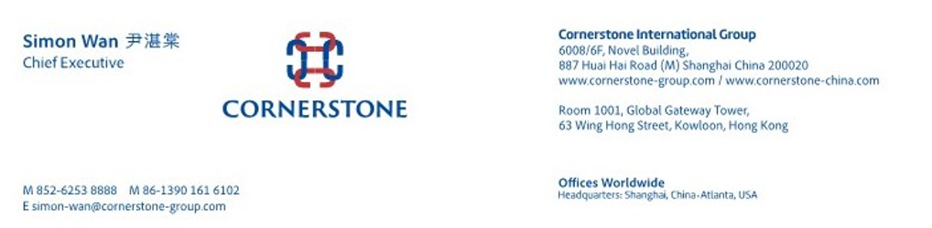

Stationery
Branded stationery should be used when conducting Cornerstone International Group business. There are two templates for letterhead:
- If you use your Cornerstone brand name (see example 1).
  - Include corporate logo.
  - Address and contact data in footer.
- If you use your non-Cornerstone brand name (see example 2).
  - Include “member of” logo.
  - Address and contact data in footer.
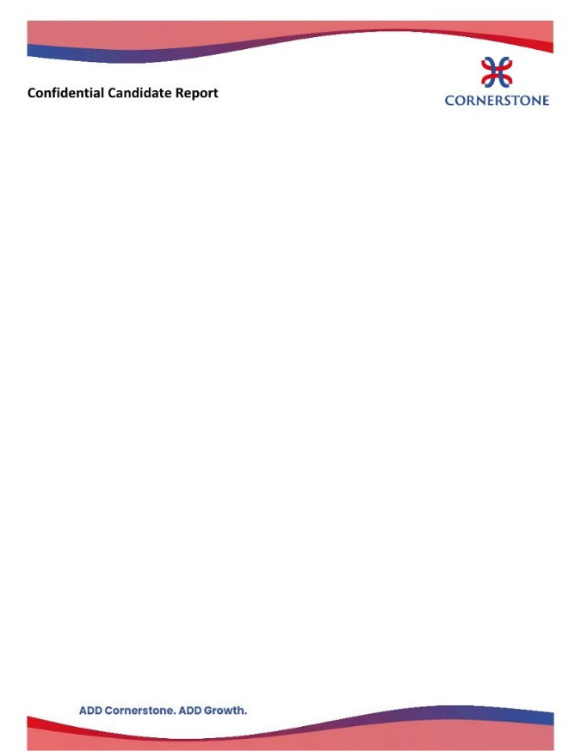
Example 1 Example 2

Marketing Material
Templates are provided on the Members Portal for print presentations, press releases and PowerPoint presentations.

Members are free to re-design and create their own marketing material, given that the visual design for one proposal or region may not be the most appropriate for another.
Any presentation of the Cornerstone International Group name and logos, however, must conform to the standards and guidelines presented in this document.


PowerPoint Presentation – preferred 16:9 format

7. Where to find resources
The materials discussed in this document are selections from the complete portfolio of branded communications of Cornerstone International Group.
This Chapter tells you where to access these graphics and/or more information.

For a complete list, consult the Resources page in the Member Portal website at

General enquiries
The Brand Standards & Guidelines is produced by the Marketing Group of Cornerstone International Group. Please address general queries to any of the following:
Blake Imeson
Web Specialist
Email: blake.imeson@gmail.com Skype: blake.imeson

Caroline Kenagy
Brand Manager
Email: caroline-kenagy@cornerstone-group.com

Support/Help line: support@conterstone-group.com

Fonts
Cornerstone International Group uses the Trajan Sans Pro font in its websites. This is a clean, modern, sans-serif font created and optimized for on-screen and print use and universally available.
If you wish to use this font (recommended) for websites, presentations and print, it is available without royalty from Google Webfonts. Please contact Blake Imeson if you need help installing the font.

Downloadable graphic files
The following logos and graphics are available for download from the Resources section of the Member Portal website located here: http://members.cornerstone-group.com/resources/
You must be a member of Cornerstone International Group and have an account to access the member site.

Logos
There is a comprehensive selection of logos in different sizes and configurations, each in an individual file for download. There are also notes suggesting the most suitable application for each format.

Letterhead
There are letterhead templates downloadable for 8.5” x 11” page size and also for A4. These templates allow you to identify your own firm as well as CIG.
We can do this for you on request.

Print presentation
There are templates for use creating Cornerstone International Group print presentations. You should customize these with your firm as presenter, or we can do it for you.
Selectable formats are for 8.5” x 11” or A4.

These are laid out in Portrait format but you can request Landscape.

PowerPoint
There are several PowerPoint presentations available in a choice of file types. They are PowerPoint 2016 files compatible with PowerPoint versions from 1997.
- PowerPoint normal: This has a .pptx extension and can be used to create your presentation.
- PowerPoint template: This has a .potx extension and should be installed in your templates folder.
- PowerPoint theme: This has a .thmx extension and is an MS Office theme to be installed in that folder.
The options for Marketing Presentations are generally offered as PowerPoint Templates, allowing you to adjust type fonts and colors.

Produced by Cornerstone International Group

Headquarters
SHANGHAI
6008/6F, Novel Bldg. 887 Huai Hai Zhong Road (M) Shanghai, 200020, China
Simon Wan
Chairman
Email: simon-wan@cornerstone-group.com

ATLANTA
1862 Independence Square, Suite A, Atlanta, Georgia 30338, USA
Larry Shoemaker
President
Email: larry-shoemaker@cornerstone-group.com

SEPTEMBER 2022

TEAMS/ZOOM Backgrounds















